How to configure WISP mode
Product line: Wireless Model number: NH326
This document is suitable for the users that want to set WISP mode
Step1：Configure an IP address for PC
Step2：Configure WISP mode
Step3：Check whether your computer can get connected
Change your PC IP address into obtain an IP address automatically
- Click the icon on the bottom right corner of your desktop.

- Click Open Network and Sharing Center
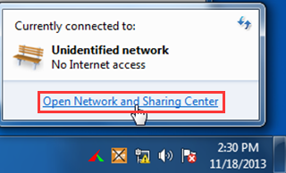
- Click Local Area Connection, and then click Properties.
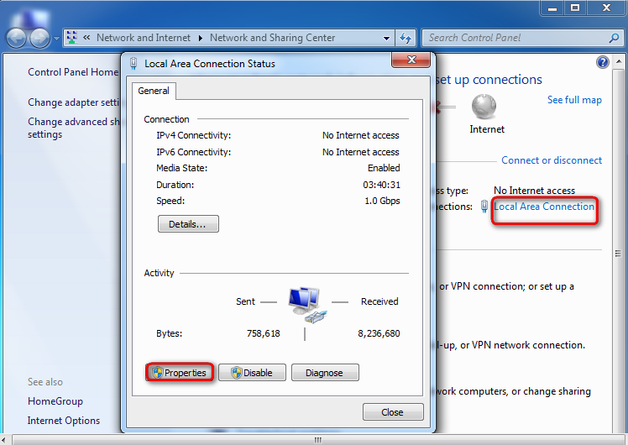
4. Find and double click Internet Protocol Version 4(TCP/IPv4).
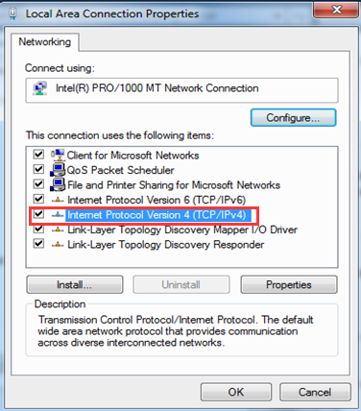
5. Select Obtain an IP address automatically and Obtain DNS server address automatically and click OK
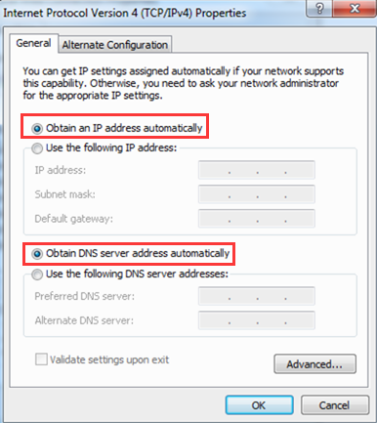
- Log in to the newly-added router’s Web Manager.
- Click Bridge and select WISP.
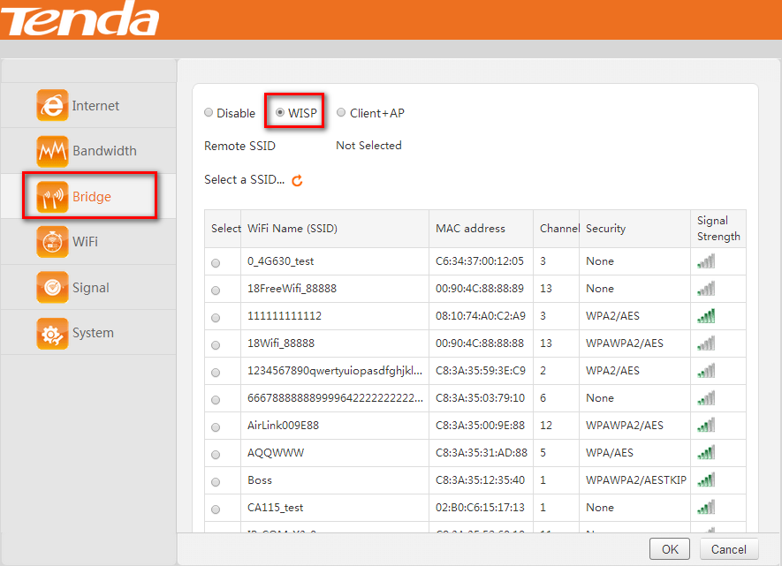
- Find and select the Wi-Fi Name (SSID) of the remote router, Tenda_135760
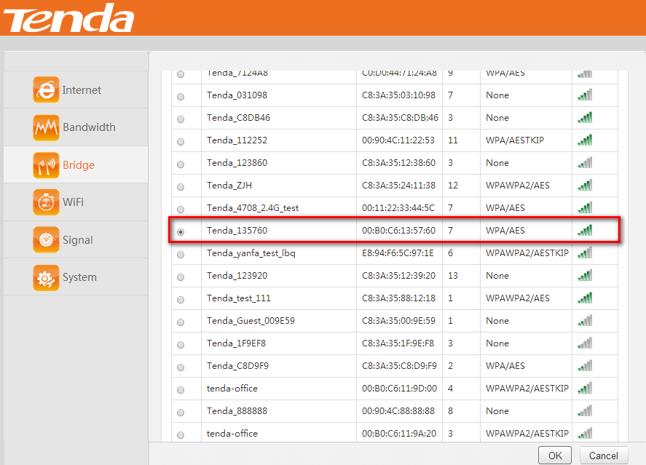
- Enter the password of the remote router which you have noted down just now, and click OK.
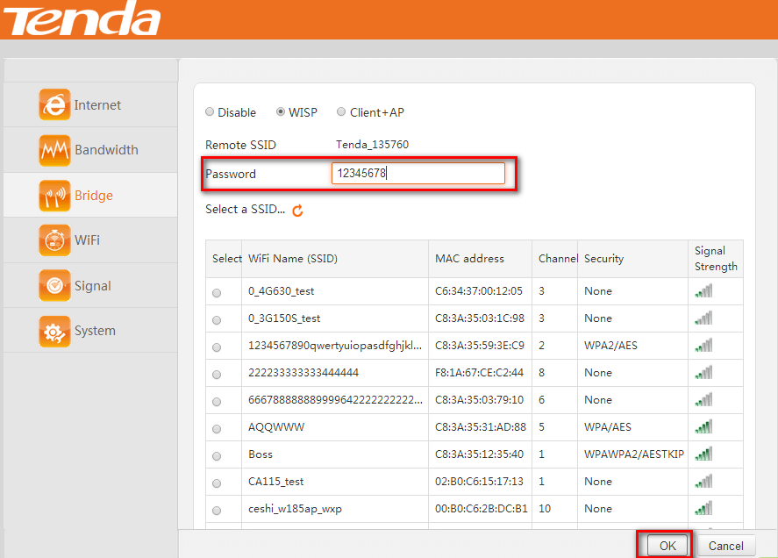
After click ok, the router will reboot.
Notice：If the prompt below appears, it indicates that the Router’s login IP and the WAN IP are in the same segment. In this case, the newly-added router’s login IP will be automatically changed into the IP address mentioned in the prompt. Just click OK.
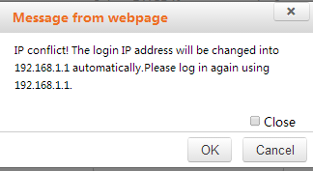

After the Router reboots, you will be directed to Internet page. Check Connection Status. If it displays Connected, it indicates that your settings are successful, and you can access the Internet via the newly-added router now.
Notice：If you have other PC need to be get connected, please connect it to the one of the LAN port or the wireless signal of the router. There is no need to configure the router again.

